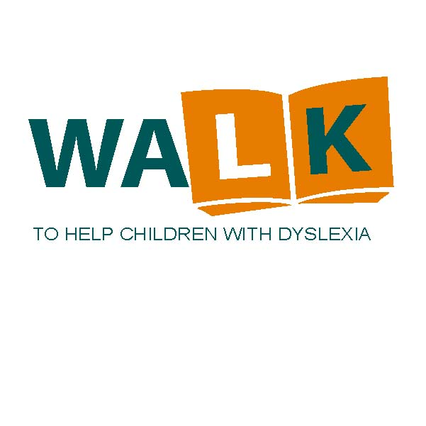

How can you help?

The Children’s Dyslexia Center of Central New York is celebrating its nineteenth year providing anafterschool program for children who have reading and writing difficulties due to dyslexia.

Our program helps children by using the Orton-Gillingham method to teach the skills necessary to overcome these difficulties.

Your help is needed and appreciated!

We need your help.

Support The Walk to Help Children with Dyslexia

Central New York  
*A Scottish Rite Charity*

8280 State Route 69

Oriskany, New York 13424

Phone: 315-736-0574

Email: centralny@cdcinc.org

“The program’s results have been Amazing – just ask the children or their parents.”

**Join us on Saturday October 7, 2023.**

The Walk begins following registration at 10:00 AM at the Dyslexia Center on the Eastern Star Home Campus in Oriskany, NY. Brochures available at the Center, via email at [centralny@cdcinc.org](mailto:centralny@cdcinc.org), by contacting Craig Cobb at [cobb3@verizon.net](mailto:c.cobb@ieee.org), by phone at 315-446-0625 or checking our website: https://www.cnyclc.org.

**Place an advertisement in our Walk program booklet.** What a great way to show your support to a great program! If you wish to participate as a sponsor, we will need your response no later than Friday, September 29, 2023.

Mail to:  **Stephen Park**

**PO Box 639**

**Old Forge, NY 13420**

**Email your Ad to:** [**pchad@frontiernet.net**](mailto:pchad@frontiernet.net)

The rates for sponsorship are as follows:

All proceeds are donated to our Center’s operational budget.

**Remember**:

**Make your tax deductible check payable to**:

**CDC-CNY103.**

Your support helps a local child in need!

Inside Full page $100

Half page $60

Quarter page $40

Eighth page $25

Patron List $15



Join us at the

OES Home Pavilion

For a

Hot Dog Roast

($5 donation)

Bake Sale

Bottle & Can Drive

List Here