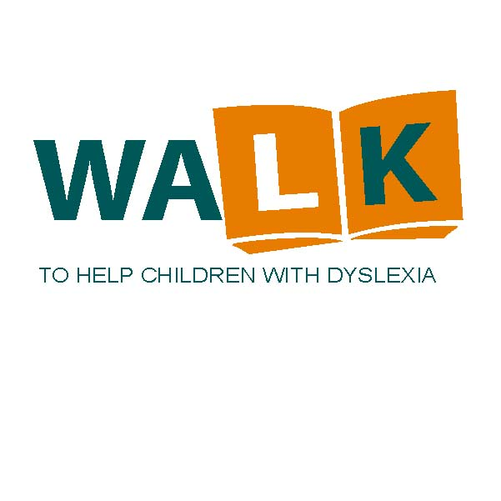

Full page - inside front, inside back,

or outside back cover $125

Inside full page $100

Half page $60

Quarter page $40

Eighth page $25

Patron List $15

How can you help?

The Children’s Dyslexia Center of Central New York is celebrating its fourteenth year providing a **free** afterschool program for children who have reading and writing difficulties due to dyslexia.

Our program helps children by using the Orton-Gillingham method to teach the skills necessary to overcome these difficulties.

Your continued help is needed and appreciated!

All proceeds go directly to the local Center’s operational budget.

All donations are tax deductible!

Remember to Make checks payable to: **CDC-CNY103.**

Your support will directly help a local child in need!

We need your help.

Support The Walk to Help Children with Dyslexia

**Join us on Saturday October 6, 2018.**

The Walk begins following registration at 9:30 am at the Dyslexia Center on the Eastern Star Home Campus in Oriskany, NY. Brochures are available at the Center, via email at [reception@cnyclc.org](mailto:reception@cnyclc.org) or contacting Craig Cobb at [cobb3@verizon.net](mailto:c.cobb@ieee.org), or by phone at 315-446-0625.

**Place an advertisement in our Walk program booklet.** What a great way to show your support to a great program! If you wish to participate as a sponsor, we will need your response no later than Wednesday, September 30, 2018.

Mail to:  **Stephen Park**

**PO Box 639**

**Old Forge, NY 13420**

**Email your Ad to:** [**pchad@frontiernet.net**](mailto:pchad@frontiernet.net)

The rates for sponsorship are as follows:

“The program’s results have been Amazing – just ask the children or their parents.”

Chicken BBQ Dinner

11 am

OES Home Pavilion

$12/ person

Advanced sales appreciated

Call-315-369-6889

Bottle & Can Drive

List Here

Children’s Dyslexia Center  
Central New York  
*A Scottish Rite Charity*

8280 State Route 69

Oriskany, New York 13424

Phone: 315-736-0574

Email: reception@cnyclc.org